USER GUIDE

METABASE

September 2018

Version 1.01

Pharmacon ITC303/309 Group

Document Revisions

|  |  |  |
| --- | --- | --- |
| Date | Version Number | Document Changes |
| 10/09/2018 | 1.01 | Initial |
|  |  |  |
|  |  |  |
|  |  |  |
|  |  |  |
|  |  |  |
|  |  |  |
|  |  |  |
|  |  |  |

Table of Contents

1 Introduction 4

1.1 Scope and Purpose 4

1.2 Process Overview 4

2 Metabase 5

2.1 Login – Administration User 5

2.1.1 To Log in to Pharmacy Error Tracker (PET) 5

2.2 Metabase 6

2.2.1 Navigate to Metabase 6

2.2.2 Metabase URL Links 9

# Introduction

## Scope and Purpose

The purpose of this user guide is to provide instructions on how to use the reporting feature - Metabase. No other features of the Pharmacy Error Tracker (PET) application will be discussed in this user guide.

* This feature is only available to a user with administrator rights.

## Process Overview

The administrator will need to log into PET using their valid username and password.

* The Welcome Page will be presented on successful login.
* The administrator will need to select Reporting via the menu bar button Reports or the Reporting button on the menu page.

# Metabase

Metabase is an open source business intelligence tool. It lets you ask questions about your data and displays answers in formats that make sense, whether that’s a bar graph or a detailed table.

Your questions can be saved for later, making it easy to come back to them, or you can group questions into great looking dashboards. Metabase also makes it easy to share questions and dashboards with the rest of your team. This user guide is based on the user guide provided by the Metabase website:

<https://www.metabase.com/docs/v0.18.1/users-guide/start.html>

To access Metabase, you will need to access PET through an administrator login.

## Login – Administration User

User must have access to the application.

User must have a valid username and password with administration rights.

### To Log in to Pharmacy Error Tracker (PET)

1. Launch the application.
2. Click in the Username field.
3. Enter username.
4. Tab or click in Password field.
5. Enter password.

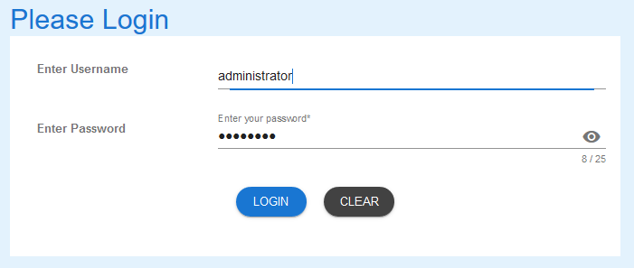

1. Select LOGIN to access PET.

NOTE: Users entering an invalid username and/or password will not beable to access PET.

## Metabase

Metabase has been provided as a reporting tool for PET. Data lists as well as graphics are available for the user. These reports can be download and shared with others.

### Navigate to Metabase

1. From the Welcome Page, there are two ways to navigate to “Metabase”:
   1. Select the “Reporting” from the list



* 1. From the Menu Bar, hover your mouse over “Reports…” and select “Reporting”



1. The Metabase login page will appear.

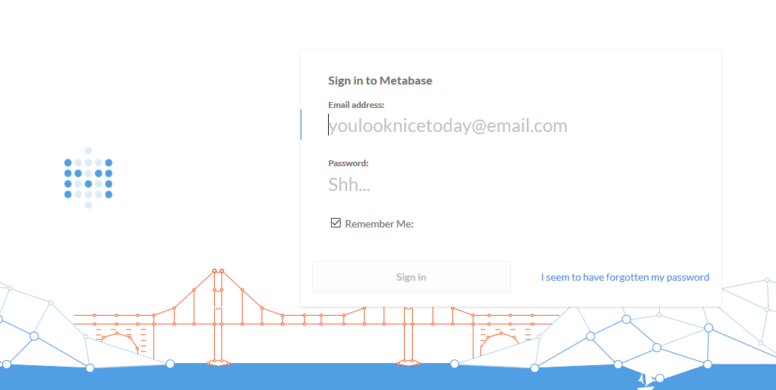

1. Enter the login and password to access Metabase.

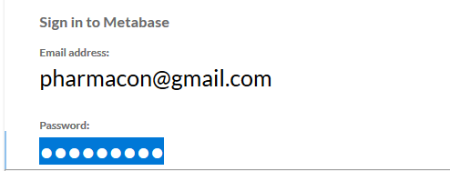

1. Select the enter and you will be taken to the welcome page.

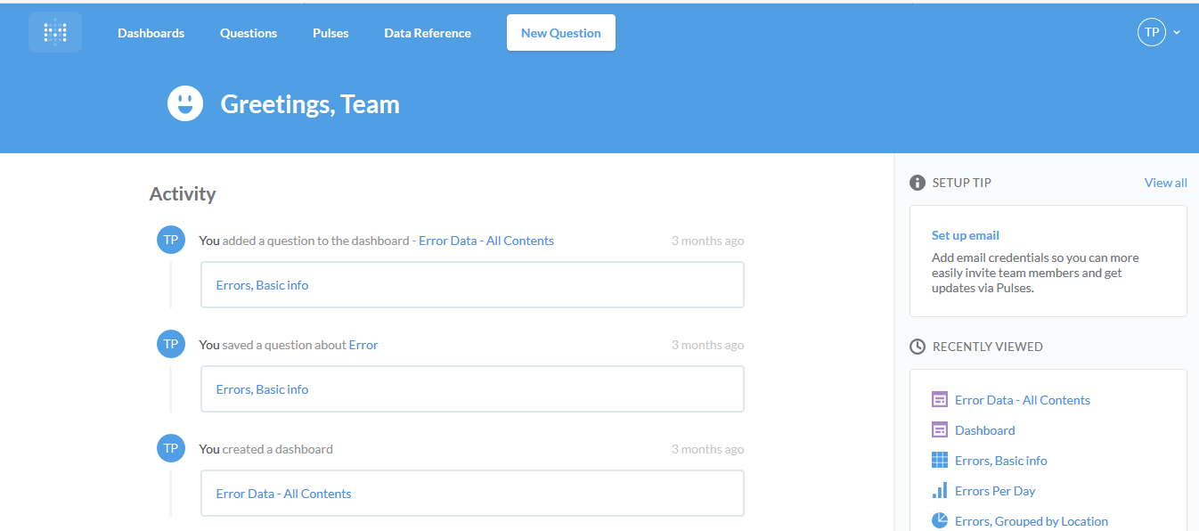

1. A direct selection of a previously saved activity can be made from the list on this page.
2. To see the dashboard, select “Dashboards” from the menu bar.



1. Saved dashboards will appear.

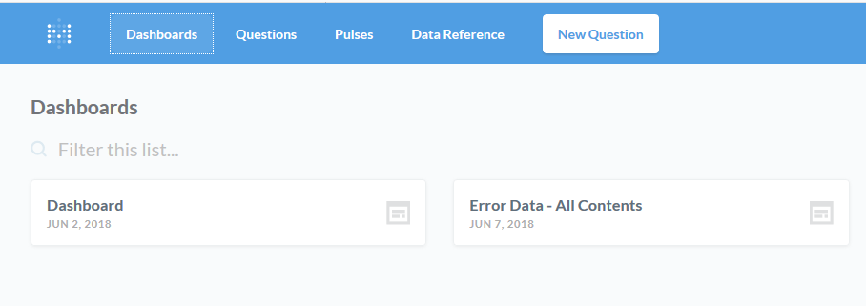

1. Selecting a dashboard will show the results of the query/queries.

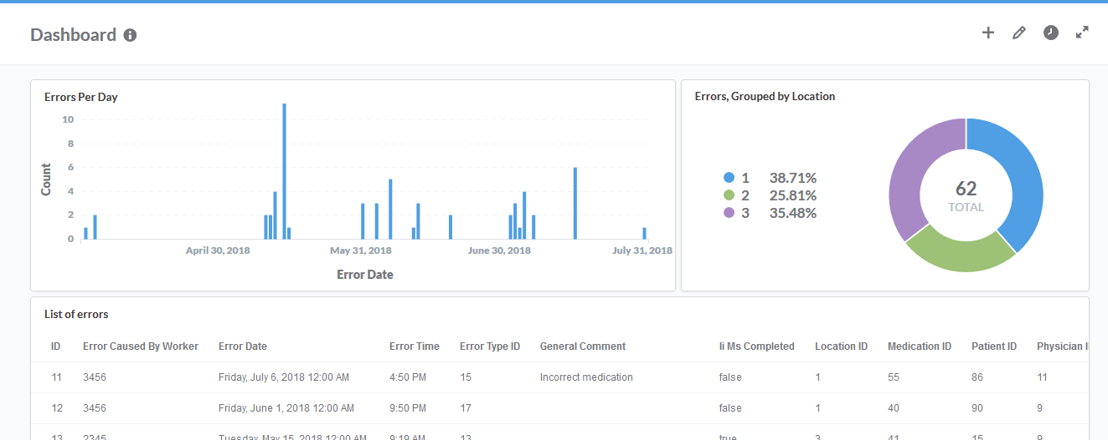

1. Selecting Questions from the menu bar will show the details of the saved questions previously asked of the database.

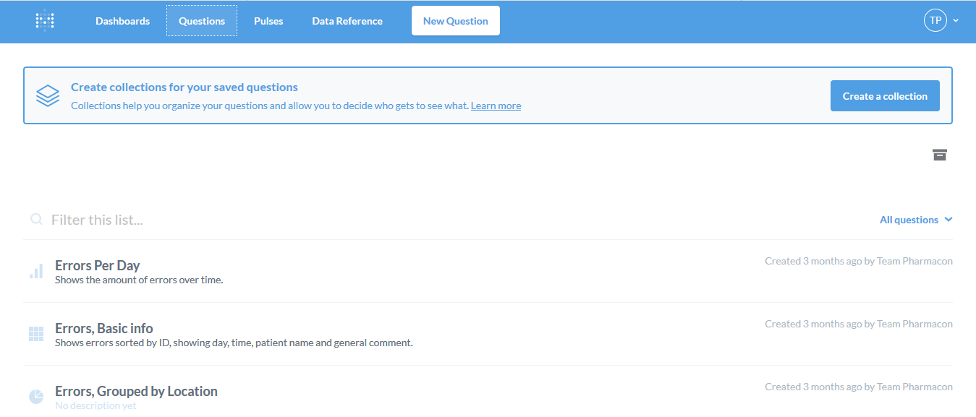

### Metabase URL Links

1. Metabase provides a user guide for the various functions available in Metabase.

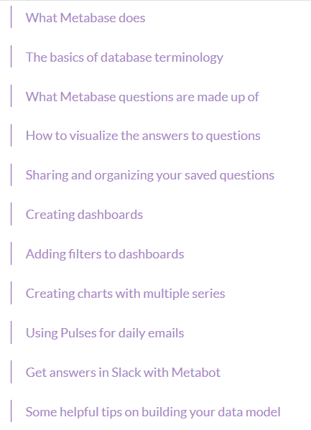

1. URL links to these various functions are listed below  
   <https://www.metabase.com/docs/v0.18.1/users-guide/01-what-is-metabase.html>

<https://www.metabase.com/docs/v0.18.1/users-guide/02-database-basics.html>

<https://www.metabase.com/docs/v0.18.1/users-guide/03-asking-questions.html>

<https://www.metabase.com/docs/v0.18.1/users-guide/04-visualizing-results.html>

<https://www.metabase.com/docs/v0.18.1/users-guide/05-sharing-answers.html>

<https://www.metabase.com/docs/v0.18.1/users-guide/06-dashboards.html>

<https://www.metabase.com/docs/v0.18.1/users-guide/07-dashboard-filters.html>

<https://www.metabase.com/docs/v0.18.1/users-guide/08-multi-series-charting.html>

<https://www.metabase.com/docs/v0.18.1/users-guide/09-pulses.html>

<https://www.metabase.com/docs/v0.18.1/users-guide/10-metabot.html>

<https://www.metabase.com/docs/v0.18.1/users-guide/11-data-model-reference.html>

If you encounter issues not addressed by this user guide, please contact your account manager for additional support.